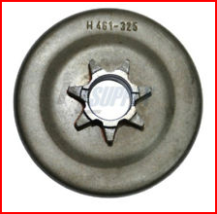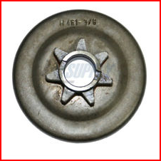
.325 Pitch Drive Sprocket 3/8 Pitch Drive Sprocket

Note: Looking at the inner ring of the donut shaped rim as a reference, notice the distance to one tooth of the .325 Pitch, and you can see the spur gear is slightly smaller than the 3/8 Pitch. Also Note that both gears are 7 tooth gears.
Again hope this helps!

